Standard Format for Preparation of

MCA Final Year Project Report



J D College of Engineering and Management, Nagpur-441501
Near Hanuman Temple, Borgoan Phata, Kalmeshwar Road,
Nagpur -441501
(An Autonomous Institute, with NAAC “A” Grade)
www.jdcoem.ac.in
Affiliated to DBATU, RTMNU & MSBTE Mumbai.

PROJECT REPORT

The arrangement of parts of MCA Final Year Project Report
The sequence in which the project report material should be arranged and bound should be as follows:
- Cover page
- Inside cover page
- Declaration Page
- Certificate
- Certificate of Approval
- Index
- Acknowledgement
- List of Figures
- List of Tables
- Abbreviations and Symbols
- Abstract
- All Chapters
- References
- Annexure
- List of papers published based on project
- Copyright certificate
- NPTEL Elite certificate
- Plagiarism Report
- Grammarly Report
- Photo Gallery
- Bibliography

The Sample Templates are given below

Templates |  | Page Number
Cover page | See Template 1 | 4
Inside cover page | See Template 2 | 5
Declaration | See Template 3 | 6
Certificate | See Template 4 | 7
Certificate of Approval | See Template 5 | 8
Index | See Template 6 | 9
Contents at Glance | See Template 6 | 9-10
Acknowledgement | See Template 7  Should not exceed one page | 10
List of Figures | See Template 8 | 12
List of Tables | See Template 9 | 13
Abbreviations and Symbols | See Template 10 | 14
Abstract | See Template 11 | 15
References | See Template 12 | 22
ANNEXURES
Paper Published | Annexure I | 23-24
Copyright certificate | Annexure II | 25
NPTEL Elite certificate | Annexure III | 26
Plagiarism Report | Annexure IV | 27
Grammarly Report | Annexure V | 28
Photo Gallery | Annexure VI | 29
Bibliography | Annexure VII | 30
Binding Details | (Only for information. Not to be included in Project Report) | 31

Roman numbers should be given to pages from Template 5 to Template 11

TITLE OF THE PROJECT REPORT
(Font: Times New Roman, size :18)

A Project Report submitted in partial fulfillment of the requirements for the award of the degree of
Master of Computer Applications
Submitted by
Name of the Student/s
Roll No.

Under the Guidance of Dr./Prof.

Master of Computer Applications
J D College of Engineering and Management, Nagpur-441501
(An Autonomous Institute, with NAAC “A” Grade)
Affiliated to DBATU, RTMNU & MSBTE Mumbai.
Year 2026-27

TITLE OF THE PROJECT REPORT
(Font: Times New Roman, size: 18)

A Project Report submitted in partial fulfillment of the requirements for the award of the degree of

Master of Computer Applications

Submitted by Name of the Student

Under the Guidance of Dr./Prof.

Master of Computer Applications

J D College of Engineering and Management, Nagpur-441501
(An Autonomous Institute, with NAAC “A” Grade)
Affiliated to DBATU. RTMNU, & MSBTE Mumbai.
Year 2026-27

DECLARATION
(Font: Times New Roman, Size: 14)

We hereby declare that the work presented in this project report entitled, “Name of the Project Title” in the subject Computer Applications in the faculty of Science and Technology is the original contribution carried out by us under the guidance of Dr./Prof._ _, Department of Computer Applications, J D College of Engineering and Management, Nagpur. This work has not been submitted to any other University or Institution for the award of any degree or diploma or certificate course.

Place: Name of Student/Students
Date:

CERTIFICATE
(Font: Times New Roman, Size: 14)

This is to certify that the project report entitled, “Name of the Project Title” in the subject Computer Applications in the faculty of Science and Technology submitted by Name of the Students to Dr. Babasaheb Ambedkar Technological University, Lonere for the award of the degree of Master of Computer Application is a bonafide record of work carried out by them under my supervision. The contents of this Project Report, in full or in parts, have not been submitted or published to any other Institute or University for the award of any degree or diploma.

(Name of the Guide)
MCA

Forwarded to:

Prof.
Project Coordinator

Prof. Swati S. Adekar
Head of the Department
CA

Dr. S. V. Sonekar
Principal

CERTIFICATE OF APPROVAL
(Font: Times New Roman, Size: 14)

This is to certify that the Project Report on TITLE OF THE PROJECT is approved work done by Name of the Students in partial fulfillment of the requirements for the award of the degree of Master of Computer Applications at J D College of Engineering & Management, Nagpur affiliated to Dr. Babasaheb Ambedkar Technological University, Lonere during the academic year 2024-25.

Name of Guide Prof. Swati S. Adekar
Guide Head of the Department

_ _ _

Project Examination held on

Internal Examiner/ Guide External Examiner

 | INDEX
Title |  | Page No.
Acknowledgement |  | i
List of Figures |  | ii
List of Tables |  | iii
Abbreviations and Symbols |  | iv
Abstract |  | v

CONTENTS AT GLANCE

Title Page No.
Chapter 1 INTRODUCTION
  - Brief Outline of Project
  - Overview of Project Report

Chapter 2 LITERATURE SURVEY
  - Literature Review
  - Research Gap
  - Problem Statement
  - Objectives

Chapter 3 RESEARCH METHODOLOGY
  - Sub-Section 1
    - Sub Sub-Section
  - Sub-Section 2

Chapter 4 EXPERIMENTATION/ IMPLEMENTATION/ SIMULATION
  - Sub-Section 1
3.1.1 Sub Sub-Section
  - Sub-Section 2

Chapter 5 RESULTS AND DISCUSSIONS Chapter 6 SUMMARY AND CONCLUSION
  - Summary
  - Conclusion

  - Scope for Future Work

REFERENCES ANNEXURES
Paper published
Copy Right Certificate NPTEL Elite Certificate Plagiarism Report Grammarly Report Photo Gallery Bibliography

ACKNOWLEDEMENT
(Font: Times New Roman, Size: 14)

We express our sincere gratitude, for giving us the opportunity to work on the project during our final year of MCA .
We owe our sincerest gratitude towards Dr. S. V. Sonekar, Principal J D College of Engineering & Management, Nagpur, for providing the platform and necessary facilities.
The constant guidance and encouragement received from Prof. Swati S. Adekar, Head, Department of Computer Applications , J D College of Engineering & Management, Nagpur, has been of great help in carrying out the project work and is acknowledged with reverential thanks.
We would like to thank Prof. , Project Coordinator, J D College of Engineering & Management, Nagpur for providing proper guidelines and continuous efforts taken towards the completion of project.
We would like to express a deep sense of gratitude and thanks profusely to our Guide Prof. , Department of Computer Applications , J D College of Engineering & Management, Nagpur. Without his/her wise counsel and able guidance, it would have been impossible to complete the project in this manner.
We would like to thank the members of the Departmental Research Committee for their valuable suggestions and healthy criticism during our presentation of the work. We express gratitude to other faculty members of Computer Applications Department, J D College of Engineering & Management, Nagpur, for their intellectual support throughout the course of this work.

Name of the students

LIST OF FIGURES

Figure No. | Title | Page No.
2.1 | Water/ Oil/ Water System
3.2 | Nature of Surfactant
4.1 | Extraction Mechanism- Type I
5.1 | Extraction Mechanism- Type II
5.2 | Structure of Span 80

LIST OF TABLES

Table No. | Title | Page No.
3.1 | Name of Table
3.2 | Name of Table
4.1 | Name of Table
5.1 | Name of Table

ABBREVIATIONS

AI Artificial Intelligence
AR Autoregressive Model
ARMA Autoregressive Moving Average Model ARMAX ARMA with external input
ASM1 Activated Sludge Model 1 ASM2 Activated Sludge Model 2 BOD Biochemical Oxygen Demand
GA Genetic Algorithm

SYMBOLS

K Specific substrate utilization rate constant kd Microbial decay coefficient
Ks Substrate concentration when growth rate is half of maximum
Q Rate of wastewater flow to the aeration tank q Specific substrate utilization rate
Qe Effluent flow rate
qm Maximum specific substrate utilization rate

ABSTRACT
(Font: Times New Roman, Size: 14)

The abstract should provide a concise, descriptive account of the project report. The abstract should not exceed one page, with the line spacing of 1.5, and should adhere to the same style as the project report manuscript. The abstract should include relevant place names, names of persons, and other proper nouns. These are useful in automated retrieval. A lower-case Roman numeral is used on the abstract page.

INTRODUCTION

Brief Outline of the Project

(This is the sample text to refer)
The title of Chapter 1 shall be Introduction. It shall justify and highlight the problem poser and define the topic and the aim and scope of the work presented in the project report. It may also highlight the significant contributions from the investigation. Numbering should be centered on the top of the page using large bold print.

Subsection (if any)

(This is the sample text to refer)
A chapter can be divided into Sections, Sub-sections and Sub-sub-sections so as to present different concepts separately. Sections and sub-sections can be numbered using decimal points, e.g., 2.2 for the second Section in Chapter 2 and 2.3.4 for the fourth Sub- section in third Section of Chapter 2. Use only Arabic Numerals with decimals. Section numbering should be left justified using large bold print.

Overview of Project Report
(This is the sample text to write overview of the project report)

Chapter 2 deals with the literature survey. The block diagram of the system is explained in Chapter 3, giving an overall view of the techniques used in the system. Chapter 4 deals with System hardware and Chapter 5 with system software and flowcharts. Chapter 6 contains result which is explained through snapshots and quantity analysis. Chapter 7 contains conclusion and scope for future work.

LITERATURE SURVEY

Literature Review

This shall normally the Chapter 2 and shall present a critical appraisal of the previous work published in the literature pertaining to the topic of the investigation. The extent and emphasis of the chapter shall depend on the nature of the investigation.

For Example,
Several researchers attempted to develop mathematical models to simulate the activated sludge process. Some of these models simulate the organic removal mechanisms in wastewater treatment field, which were included in Jorgensen and Gromiec (1985), Henze (1986), Henze et al. (1987a), Tang et al. (1987), and Van Niekerk et al. (1988).

Research Gap
Initially the user is asked to swipe the RFID card. The Raspberry pi compares the unique tag ID with the data base. If the tag ID matches, the user is asked to scan the finger. Once the user identity is authenticated, the commodity and quantity can be selected through voice commands. If the commodity and quantity are valid, the system dispenses the valid commodity.

Problem Statement
A sybble attacker can damage to the several attacks in several ways. The traditional approach to prevent such attacks are trusted and certified. However, this approach is not suitable for mobile ADHOC networks because it usually require costly initial set up.

Objectives
    - To implement attack detection technique without hardware.
    - To detect and remove masquerade attack in the network.

RESEARCH METHODOLOGY

Section 1
Research Methodology includes design or approach (quantitative, qualitative or algorithmic), population and / or sample, collection and tabulation of data and data analysis procedures.

Subsection (if any) Equations
All the equations should be typed in equation editor and should be properly numbered For Example,
∆X α X ∆t (2.1)

Section 2

Table No. 3.1 Desorption Study

Cycle | Metal/  Adsorbent | Copper |  | Lead
Cycle | Metal/  Adsorbent | RRH | RHA | RRH | RHA
1 | Adsorption | 73% | 97.5% | 81% | 98%
1 | Desorption | 99% | 99.5% | 98.5% | 99%
2 | Adsorption | 40% | 30% | 80% | 38%
2 | Desorption | 99% | 99% | 98% | 99%

EXPERIMENTATION/ IMPLEMENTATION/ SIMULATION

Section 1
Experimentation/Implementation/Simulation includes carrying out the activities described in your methodology. It can also include Fabrication/ Experiment / design of experiments, description of equipment and materials, methods of analysis etc.

Subsection (if any)
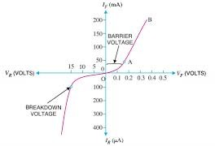

Figure 4.1 V-I Characteristics of PN junction Diode

Section 2

………………

RESULTS AND DISCUSSIONS

Section 1

This shall form the penultimate chapter of the project report and shall include a thorough evaluation of the investigation carried out and bring out the contributions from the study. The discussion shall logically lead to inferences and conclusions as well as scope for possible further future work.

Subsection (if any)
………………

Section 2

………………

SUMMARY AND CONCLUSION

Summary

This will be the final chapter of the project report. A brief report of the work carried out shall form the first part of the Chapter. Conclusions derived from the logical analysis presented in the Results and Discussions Chapter shall be presented and clearly enumerated, each point stated separately. Scope for future work should be stated lucidly in the last part of the Chapter.

Conclusion

……………….

Scope for Future Work

………………..

Template 12

REFERENCES

Conferences
- Bai Y.and Basheer, P.A.M. (2003), “Influence of Furnace Bottom Ash on properties of concrete,” Proceedings of the Institution of Civil Engineers, Structure and Buildings 156, February 2003, Issue 1, pp. 85-92.

Journals
- D. C. L. Teo, M. A. Mannan, and J. V. Kurian (2006), “Flexural Behaviour of reinforced lightweight concrete beams made with oil palm shell (OPS), ” Journal of Advanced Concrete Technology, vol. 4, no. 3, pp. 1–10.

Books
- Abraham Silberschatz, Peter Baer Galvin, Greg Gagne, “Operating System Concepts”, Ninth Edition, Wiley Publication.

Web data sheets (Optional)
- µA741 General-Purpose Operational Amplifiers datasheet (Rev. G)

Web Links
- Proper URL to be mentioned here as given below: https://developer.ibm.com/technologies/iot/articles/iot-lp101-connectivity-network-protocols/

Annexure I

Details of Paper/s Published

Published papers should be placed over here.
  - Requirement for the submission of Project Report (For Final Year):
Minimum of one paper in IEEE/ SPRINGER/ ELSVIER / ACM journals / IEEE/ SCI/ IJE/SAE/ ICJ/ASME/ UGC Approved unpaid Journals with Journal Number.

  - The certificates of the paper presentation should be attached after published paper. (Sample certificate is attached in the next page.)

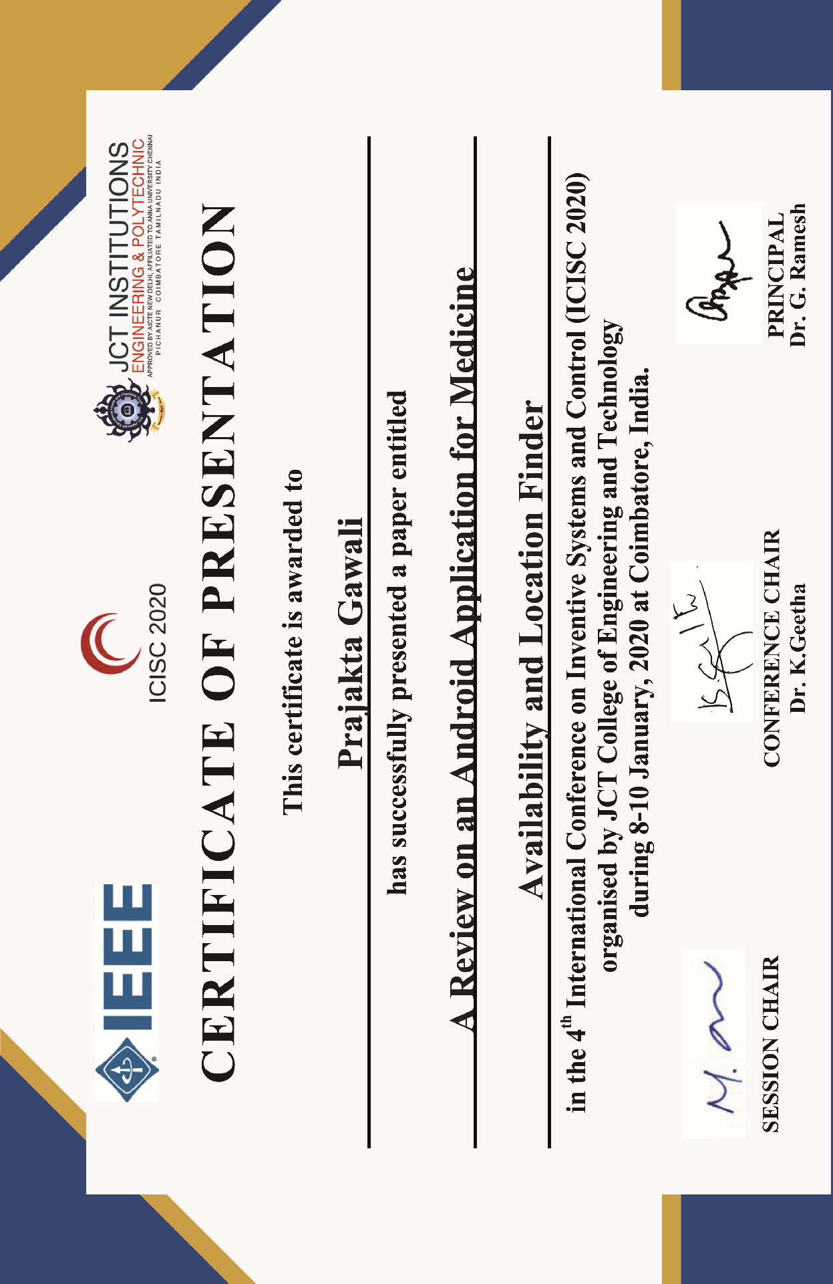

Copyright Certificate

Copyright certificate for Seminar PPT/Poster is to be attached here.

NPTEL Elite Certificate

Individual NPTEL passing with Elite category certificate is mandatory for submission of Project Report and to be attached here.

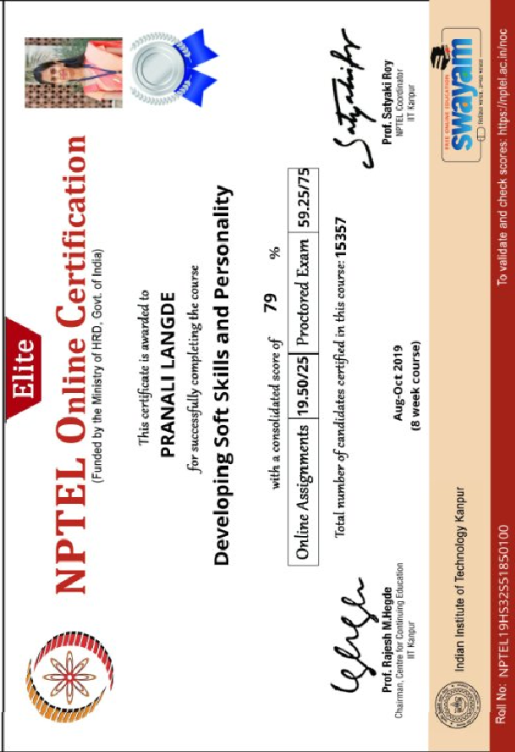

Plagiarism Report

The project report should be checked for Plagiarism and the report should be attached here. (Max. 30% Plagiarism allowed).

Grammarly Report

The project report should be checked online from Grammarly software and the report should be attached here. The link to check is: https://www.grammarly.com/grammar-check
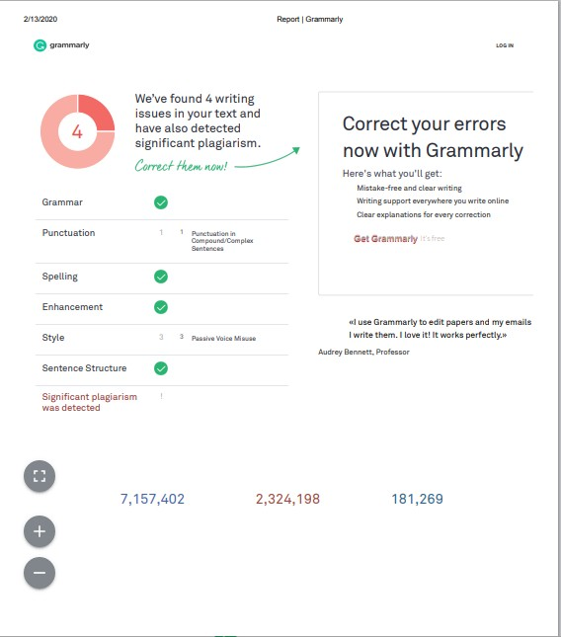

Photo Gallery
(Color Print)

The photo gallery should include images captured while working on project as well as achievements such as prizes in project competitions, paper presentations, etc.

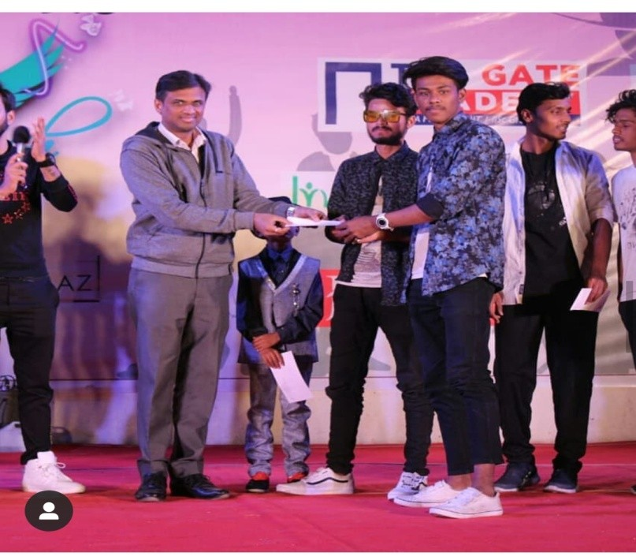
Image captured during execution of the project
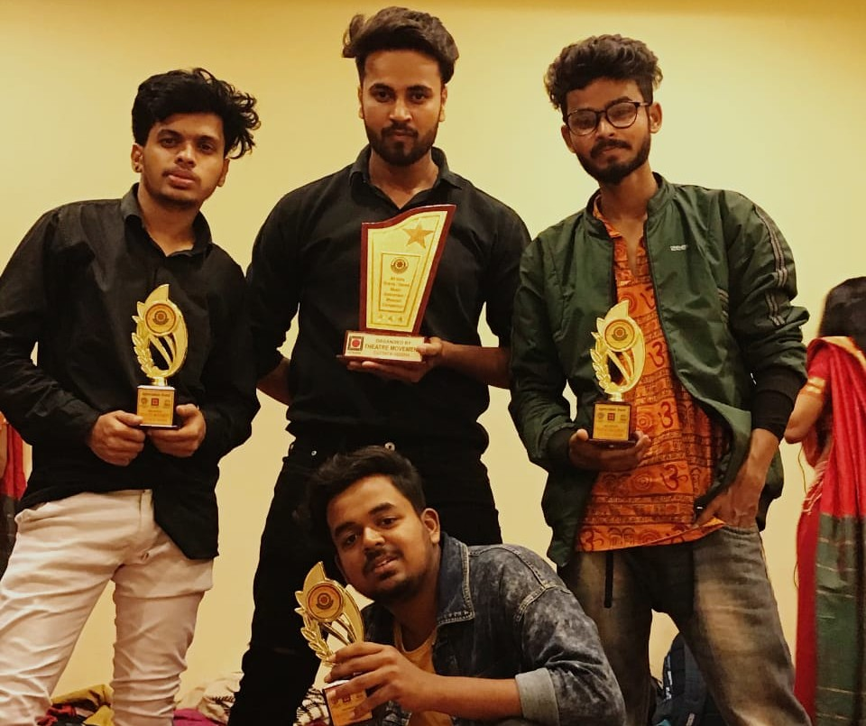

Image captured during execution of the project

Bibliography

This is the sample format of Bibliography. It should include passport photograph of individual student in college uniform with his/her brief introduction.
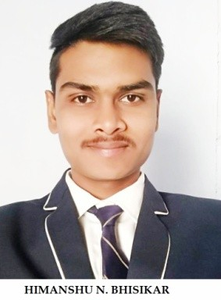
Mr. Himanshu Bhimsikar is a pursuing Bachelor of Engineering in Computer Science and Engineering from J D College of Engineering and management, Nagpur. He has participated in various project competitions and workshops. (The students achievements should be included in 4 to 5 lines.)

Mr. Himanshu Bhimsikar is a pursuing Bachelor of Engineering in Computer Science and Engineering from J D College of Engineering and management, Nagpur. He has participated in various project competitions and workshops. (The students achievements should be included in 4 to 5 lines.)

Mr. Himanshu Bhimsikar is a pursuing Bachelor of Engineering in Computer Science and Engineering from J D College of Engineering and management, Nagpur. He has participated in various project competitions and workshops. (The students achievements should be included in 4 to 5 lines.)

Mr. Himanshu Bhimsikar is a pursuing Bachelor of Engineering in Computer Science and Engineering from J D College of Engineering and management, Nagpur. He has participated in various project competitions and workshops. (The students achievements should be included in 4 to 5 lines.)

Binding Details
(Not to be included in Project Report. Only for Reference)

The project report should be covered bound in BLACK background with Golden
print. The side cover design is as per sample given below (Side Cover Sticker).

MCA Title of Project Department abbreviation 2024-25

1) Page Dimensions And Margin

Paper size : 80 gsm. Standard A4 size (210 mm X 297 mm)

Margins
Top edge : 1 inch (25 mm) Left side : 1 ½ inch (38 mm) Bottom edge : 1 inch (25 mm) Right side : 1 inch (25 mm)
Print out : Laserjet or Inkjet printer, printed on only one side Font size : Times New Roman of 12 pts (for running text) Spacing : 1.5 line spacing
Chapters : 14 pts bold Centre aligned (Capital Letters) Sections : 12 pts bold left aligned (Capital Letters) Subsections : 12 pts bold left aligned (Title case)
Page numbers (Chapters) : Bottom – centered – 12 pts (1, 2, 3…)
Page numbers (Templates): Bottom – centered – 12 pts / Roman numerals (i, ii, iii….) Binding : Soft binding (edge with black color strip)

Number of copies:

Total number of PROJECT REPORT = Number of students in a group (N)
+ THREE (1. Departmental Library
  - Central library
  - Project Guide)
Note: The softcopy of project related tools/ software, Project Report, and all annexure, etc should be submitted in CDs attached with each Project Report.

